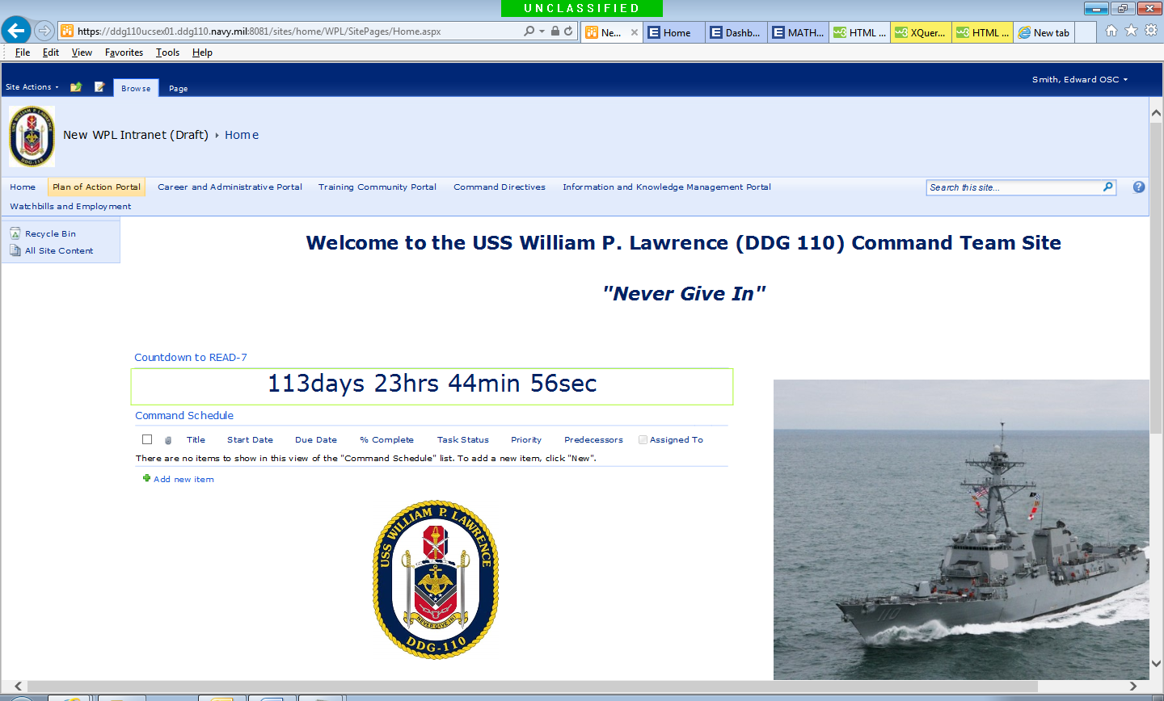

*<!DOCTYPE HTML>*

*<html>*

*<head>*

*<meta name="viewport" content="width=device-width, initial-scale=1">*

*<style>*

*p {*

*text-align: center;*

*font-size: 30px;*

*margin-top:0px;*

*}*

*</style>*

*</head>*

*<body>*

*<p id="demo"></p>*

*<script>*

*// Set the date we're counting down to*

*var countDownDate = new Date("Oct 15, 2018 15:37:25").getTime();*

*// Update the count down every 1 second*

*var x = setInterval(function() {*

*// Get todays date and time*

*var now = new Date().getTime();*

*// Find the distance between now an the count down date*

*var distance = countDownDate - now;*

*// Time calculations for days, hours, minutes and seconds*

*var days = Math.floor(distance / (1000 * 60 * 60 * 24));*

*var hours = Math.floor((distance % (1000 * 60 * 60 * 24)) / (1000 * 60 * 60));*

*var minutes = Math.floor((distance % (1000 * 60 * 60)) / (1000 * 60));*

*var seconds = Math.floor((distance % (1000 * 60)) / 1000);*

*// Output the result in an element with id="demo"*

*document.getElementById("demo").innerHTML = days + "days " + hours + "hrs "*

*+ minutes + "min " + seconds + "sec ";*

*// If the count down is over, write some text*

*if (distance < 0) {*

*clearInterval(x);*

*document.getElementById("demo").innerHTML = "EXPIRED";*

*}*

*}, 1000);*

*</script>*

*</body>*

*</html>*

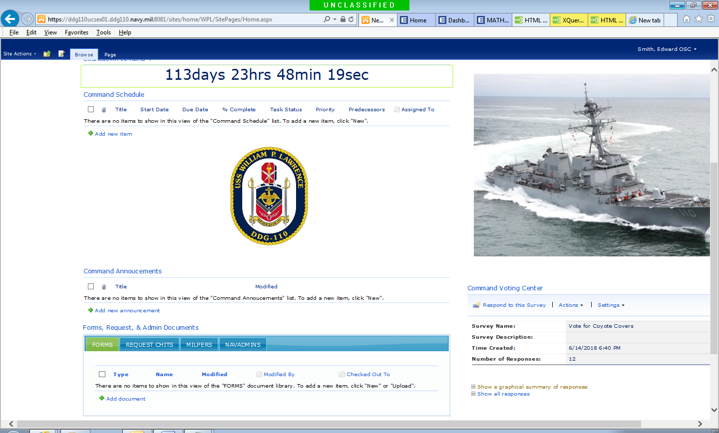

*<link type="text/css" rel="stylesheet" href="//ajax.googleapis.com/ajax/libs/jqueryui/1.10.0/themes/start/jquery-ui.css" />*

*<!-- Reference jQuery on the Google CDN -->*

*<script type="text/javascript" src="//ajax.googleapis.com/ajax/libs/jquery/1.8.3/jquery.min.js"></script>*

*<!-- Reference jQueryUI on the Google CDN -->*

*<script type="text/javascript" src="//ajax.googleapis.com/ajax/libs/jqueryui/1.10.0/jquery-ui.min.js"></script>*

*<script type="text/javascript">*

*jQuery(document).ready(function($) {*

*$(".s4-wpcell").hide();*

*$(".s4-wpcell-plain").hide();*

*//Put the Web Part Title for all the Web Parts you wish*

*//to put into the tabbed view into the array below.*

*setTimeout(function() {*

*HillbillyTabs(["****FORMS","REQUEST CHITS","MILPERS","NAVADMINS****"]);*

*}, 800);*

*});*

*function HillbillyTabs(webPartTitles)*

*{*

*for(index in webPartTitles)*

*{*

*var title = webPartTitles[index];*

*$("#HillbillyTabs").append('<li><a href="#Tab'+index+'" id="TabHead'+index+'" onclick="SetActiveTab(this.id);">'+*

*title+'</a></li>').after('<div id="Tab'+index+'"></div>');*

*$("span:contains('"+title+"')").each(function(){*

*if ($(this).text() == title){*

*var webPart = $(this).hide().closest("span").closest("[id^='MSOZoneCell_WebPart']");*

*if ($(webPart).contents().html() != undefined)*

*{*

*webPart = $(webPart).contents();*

*}*

*$("#Tab" + index).append((webPart));*

*}});*

*}*

*$("#tabsContainer").tabs();*

*$(".s4-wpcell").show();*

*$(".s4-wpcell-plain").show();*

*}*

*function SetCookie(id)*

*{*

*var date = new Date();*

*//make the cookie expire in 5 minutes*

*date.setTime(date.getTime()+(300*1000));*

*var expires = "; expires="+date.toGMTString();*

*document.cookie = "ActiveTab="+id+expires+"; path=/";*

*}*

*function ShowActiveTab()*

*{*

*var name = "ActiveTab";*

*var cookieArray = document.cookie.split(";");*

*for (index in cookieArray)*

*{*

*var keyValuePair = cookieArray[index].split("=");*

*var key = keyValuePair[0];*

*key = key.replace(/^\s+|\s+$/g, "");*

*if (key == name)*

*{*

*var value = keyValuePair[1];*

*$("#" + value).click();*

*return;*

*}*

*}*

*}*

*</script>*

*<div id="tabsContainer"><ul id="HillbillyTabs"></ul></div>*

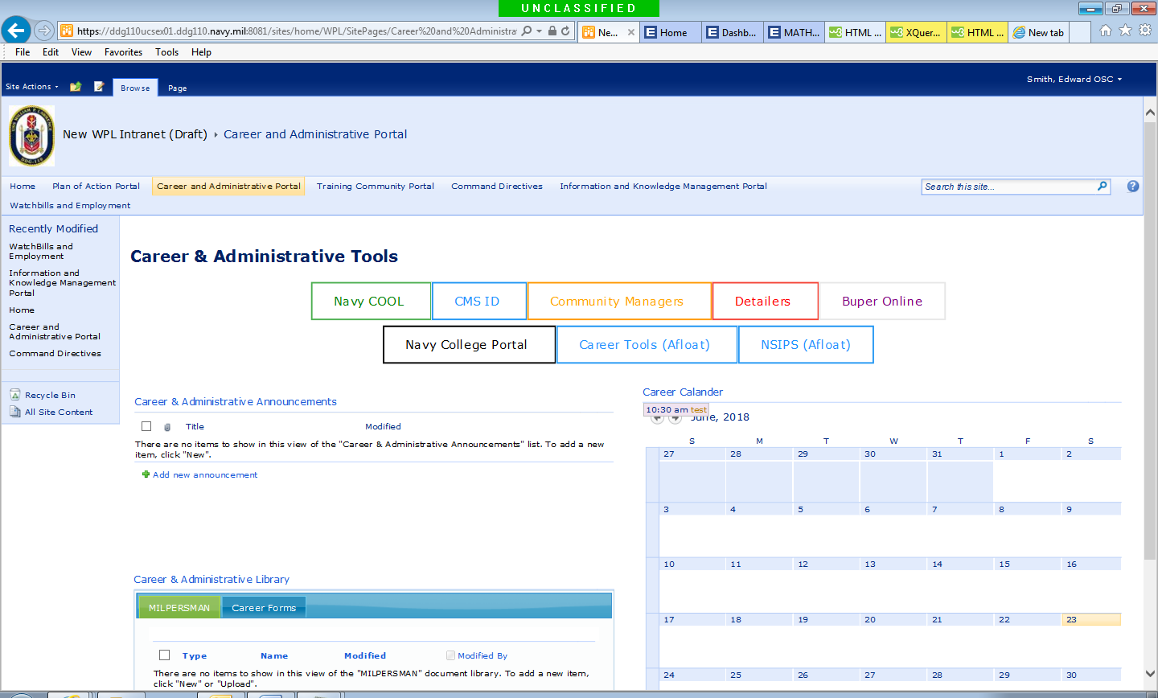

*<!DOCTYPE html>*

*<html>*

*<head>*

*<meta name="viewport" content="width=device-width, initial-scale=1">*

*<style>*

*.btn {*

*border: 2px solid black;*

*border-radius: 5px;*

*background-color: white;*

*color: black;*

*padding: 14px 28px;*

*font-size: 16px;*

*cursor: pointer;*

*}*

*/* Green */*

*.success {*

*border-color: #4CAF50;*

*color: green;*

*}*

*.success:hover {*

*background-color: #4CAF50;*

*color: white;*

*}*

*/* Blue */*

*.info {*

*border-color: #2196F3;*

*color: dodgerblue*

*}*

*.info:hover {*

*background: #2196F3;*

*color: white;*

*}*

*/* Orange */*

*.warning {*

*border-color: #ff9800;*

*color: orange;*

*}*

*.warning:hover {*

*background: #ff9800;*

*color: white;*

*}*

*/* Red */*

*.danger {*

*border-color: #f44336;*

*color: red*

*}*

*.danger:hover {*

*background: #f44336;*

*color: White;*

*}*

*/* Gray */*

*.default {*

*border-color: #e7e7e7;*

*color: Purple;*

*}*

*.default:hover {*

*background: #e7e7e7;*

*}*

*</style>*

*</head>*

*<body>*

*<h1>Career & Administartor Tools</h1>*

*<a href="https://www.cool.navy.mil/"button class="btn success">Navy COOL</button>*

*</a>*

*<a href="https://www.cmsid.navy.mil/"button class="btn info">CMS ID</button>*

*</a>*

*<a href="http://www.public.navy.mil/bupers-npc/enlisted/community/Pages/default.aspx/"button class="btn warning">Community Managers</button>*

*</a>*

*<a href="http://www.public.navy.mil/bupers-npc/enlisted/detailing/Pages/default2.aspx/"button class="btn danger">Detailers</button>*

*</a>*

*<a href="https://www.bol.navy.mil/"button class="btn default">Buper Online</button>*

*</a>*

*<a href="http://www.navycollege.navy.mil/"button class="btn Success">Navy College Portal</button>*

*</a>*

*<a href="http://ddg110usv01/cta/cta.aspx"button class="btn info">Career Tools (Afloat)</button>*

*</a>*

*<a href="https://nsipswebafloat/psp/NEDB/?cmd=login&languageCd=ENG"button class="btn info">NSIPS (Afloat)</button>*

*</a>*

*</body>*

*</html*

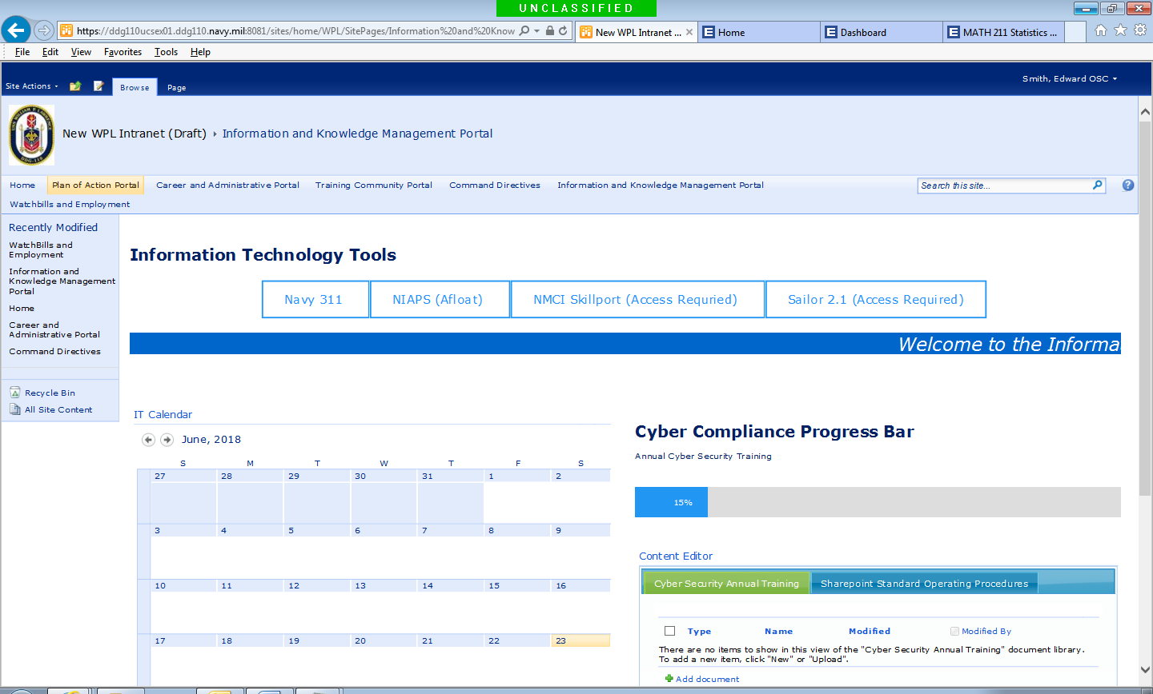

*<!DOCTYPE html>*

*<html>*

*<head>*

*<meta name="viewport" content="width=device-width, initial-scale=1">*

*<style>*

*\* {box-sizing: border-box}*

*.container {*

*width: 100%;*

*background-color: #ddd;*

*}*

*.skills {*

*text-align: right;*

*padding-right: 20px;*

*line-height: 40px;*

*color: white;*

*}*

*.html {width: 10%; background-color: #4CAF50;}*

*.css {width: 15%; background-color: #2196F3;}*

*.js {width: 20%; background-color: #f44336;}*

*.php {width: 25%; background-color: #808080;}*

*</style>*

*</head>*

*<body>*

*<h1>Cyber Compliance Progress Bar</h1>*

*<p>SAAR-N Form Completion</p>*

*<div class="container">*

*<div class="skills html">10%</div>*

*</div>*

*<p>Annual Cyber Security Training</p>*

*<div class="container">*

*<div class="skills css">15%</div>*

*</div>*

*<p>(Placeholder)</p>*

*<div class="container">*

*<div class="skills js">20%</div>*

*</div>*

*<p>(Placeholder)</p>*

*<div class="container">*

*<div class="skills php">25%</div>*

*</div>*

*</body>*

*</html>*



*<div align="center" class="ms-rteFontSize-4"><marquee width="100%" bgcolor="#0066cc" scrolldelay="5" direction="left" behavior="scroll" scrollamount="5" loop="15"><span style="color: #ffffff"><span><em>Welcome to the Information Technology Portal....please checkout our Sharepoint standard operating procedures in the tab below.</em></span></span></marquee></div>*